**NETWORK BASED APPLICATION DEVELOPMENT**

**ITIS 5166**

**USER MANUAL**

**Table of contents**

|  |  |  |
| --- | --- | --- |
| **Sr. No** | **Title** | **Page No** |
| **1** | **Home** | **2** |
| **2** | **Login** | **3** |
| **3** | **Admin Role** | **3** |
| **4** | **Product list- admin** | **4** |
| **5** | **Add product- Admin** | **5** |
| **6** | **Assign role to users- Admin** | **5** |
| **7** | **Update- Admin** | **6** |
| **8** | **Delete- Admin** | **6** |
| **9** | **Search** | **7** |
| **10** | **Customer** | **8** |
| **11** | **Add to cart- Customer** | **8** |
| **12** | **Update user** | **9** |
| **13** | **Remove item- Customer** | **10** |
| **14** | **Checkout- customer** | **11** |

**Application Name: BOOK WORLD**

The application has two types of users.

The user can either be an ‘Admin’ or ‘Customer

**HOME:**



**LOGIN:**

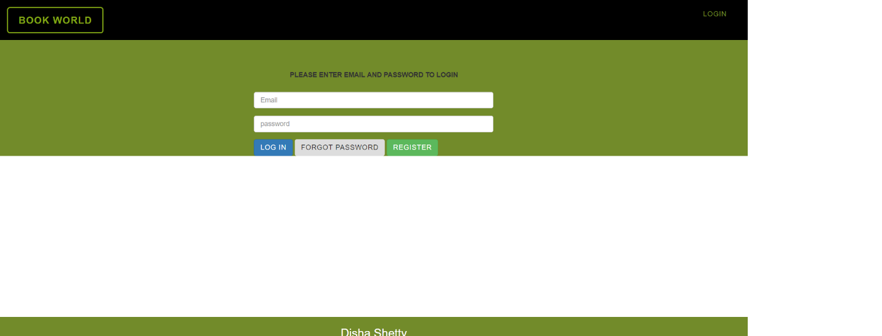

**ADMIN**

The admin can make changes to the product list. He can add new products or delete the existing ones. He can assign roles to users of the system. He can make a user either the admin or a customer.

An ‘Admin’ needs to know the products available, their prices and other details to update the database regularly. He also needs to know which user to assign which role. An admin can reset his password.

Email id: [kdishashetty2992@gmail.com](mailto:kdishashetty2992@gmail.com)

Password: shetty

**Product list- admin can view all books here and make necessary changes**

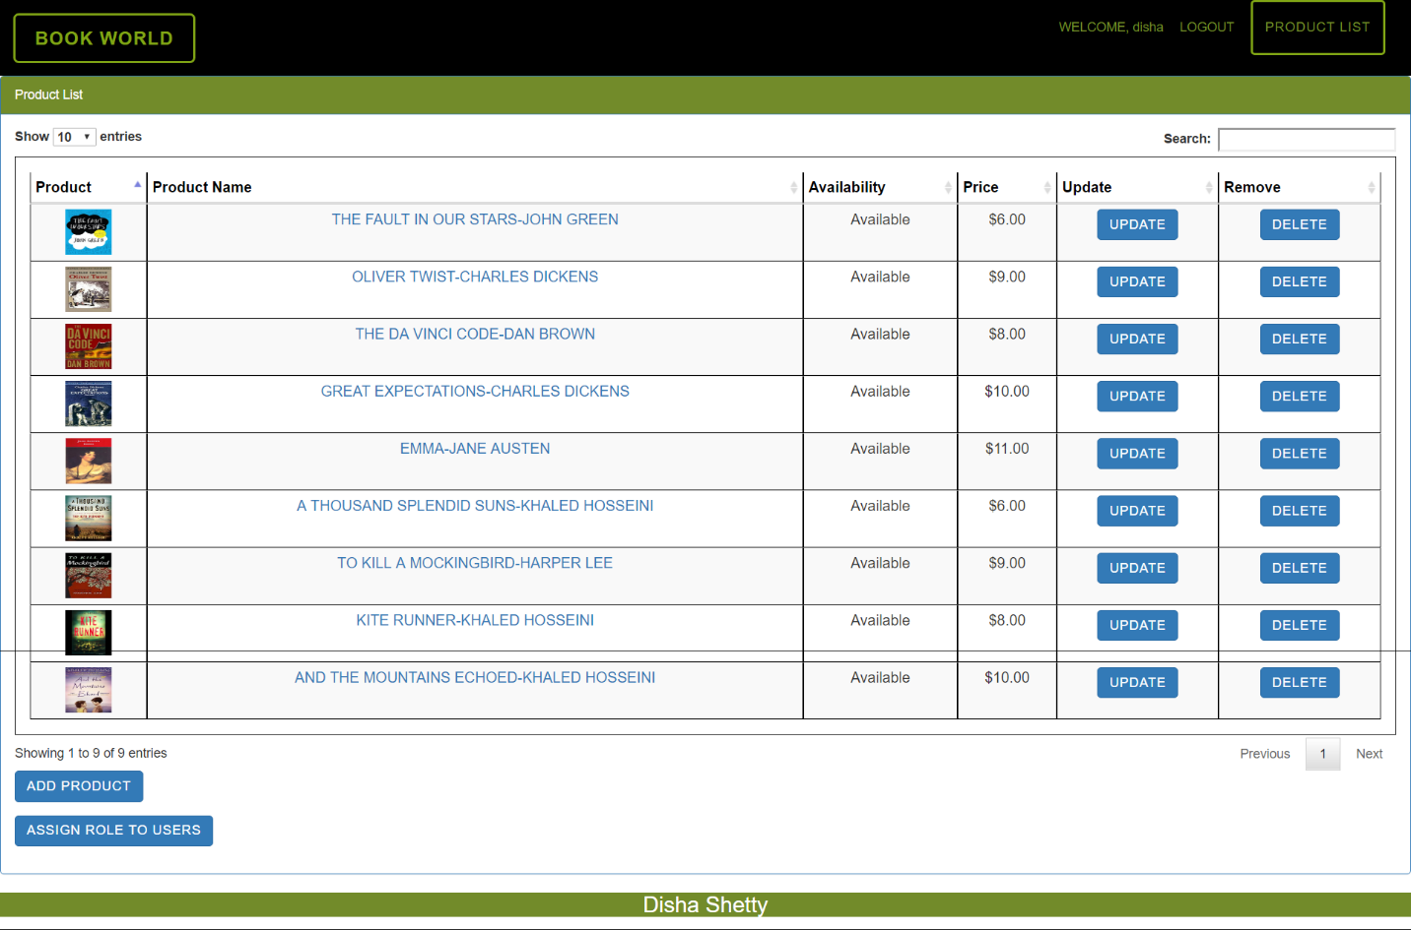

**Add product- Admin can add new books to the product list**

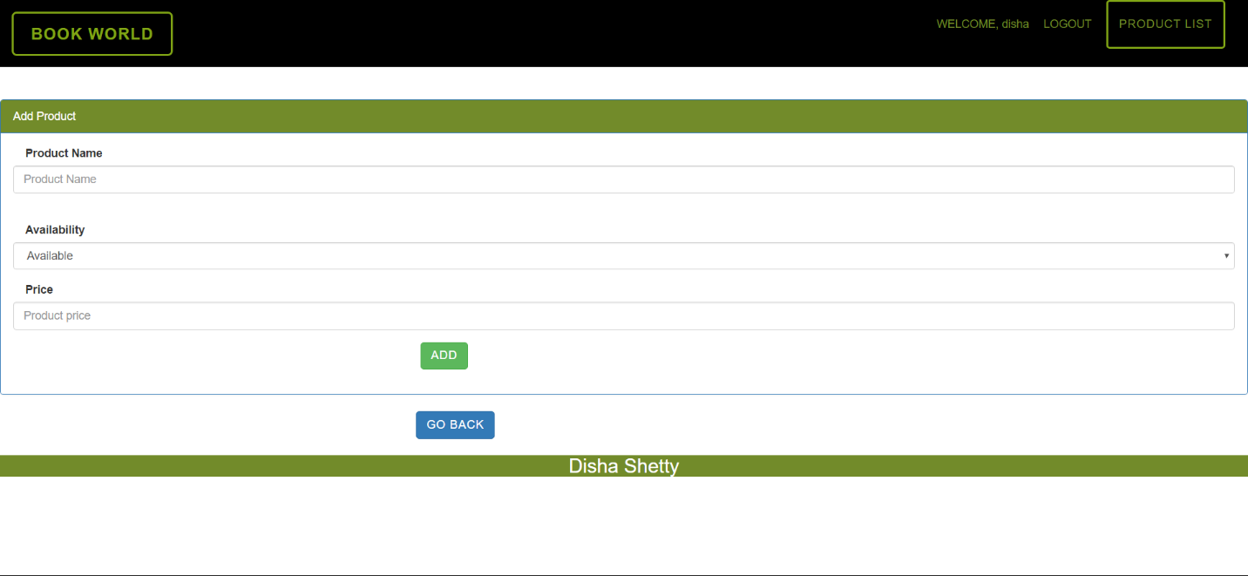

**Assign role to users- Admin can assign roles to different users**

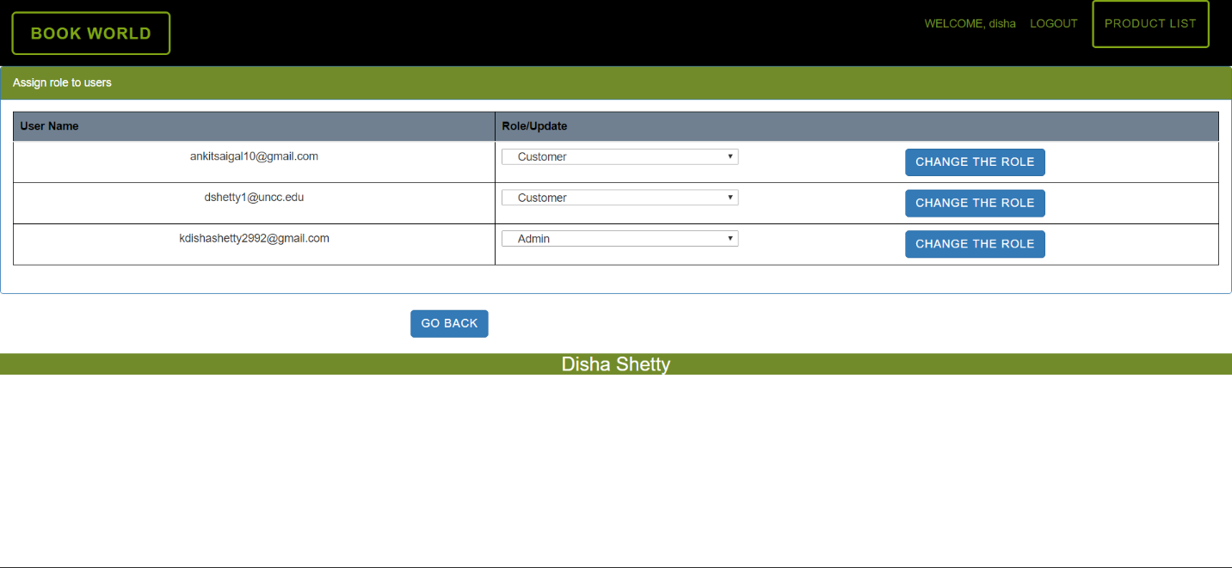

**Update- Admin can update the details of each book and make necessary changes**

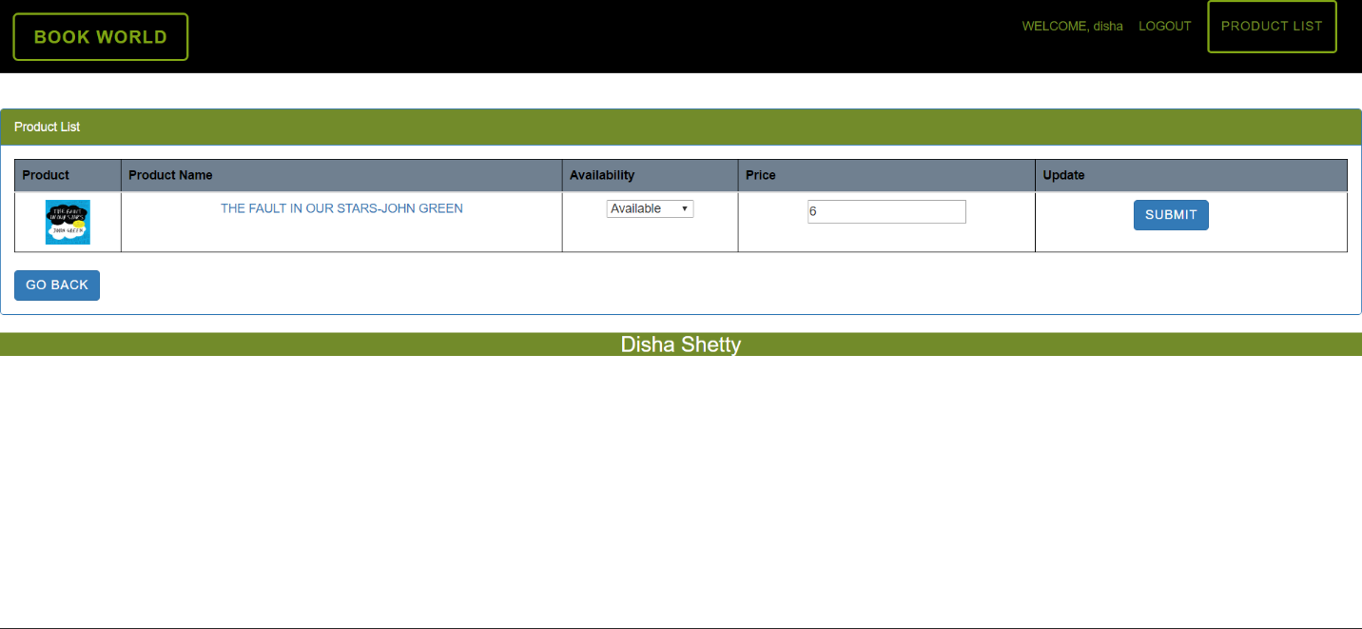

**Delete- Admin can delete books from the product list**

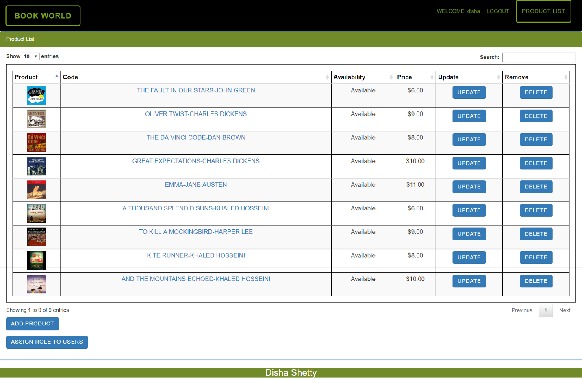

**Search- a user can search for any book using search box**

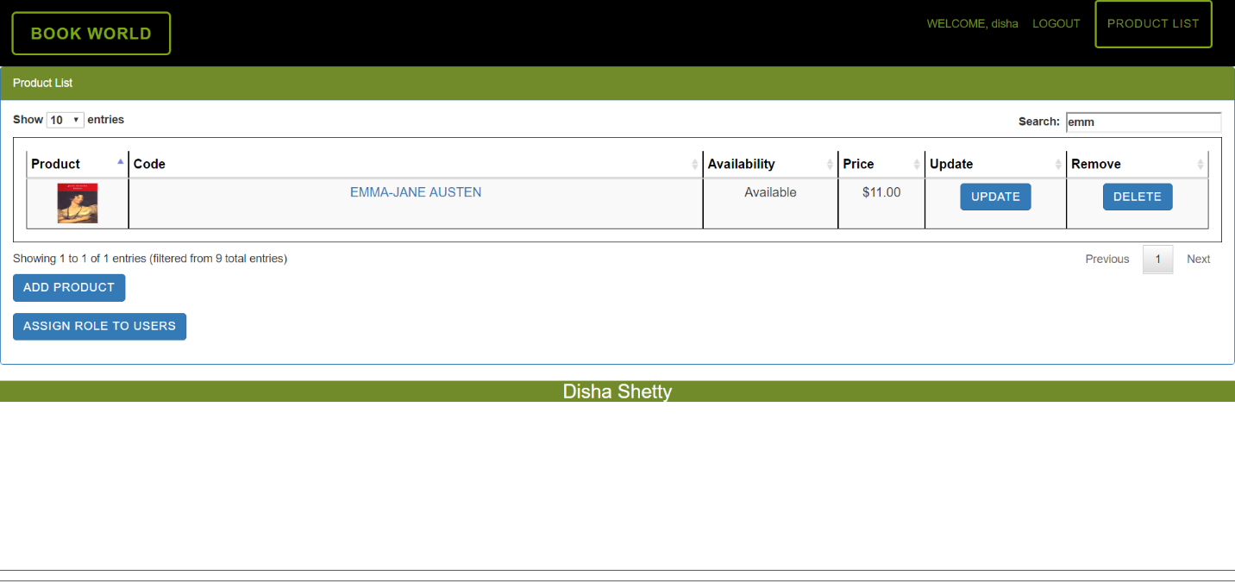

**CUSTOMER**

Customer- The customer can log into the system and see the different books available, their price and can add the books they wish to buy to their cart and then checkout.A ‘Customer’ needs to know his login id and password. He can reset his password if he needs to.

**Product list- Customer can view books**

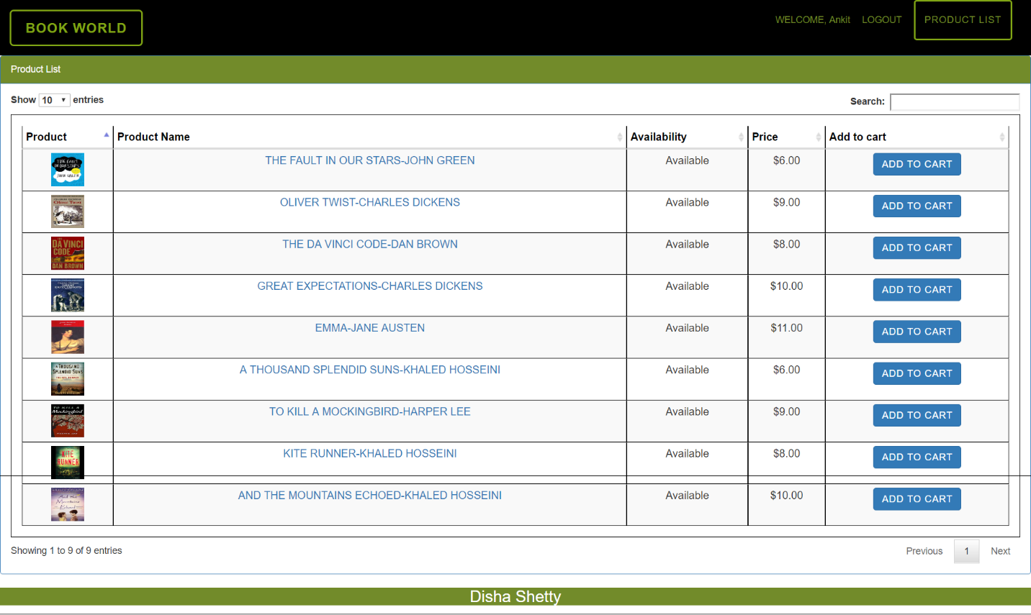

**Add to cart- Customer can add a book to their cart**

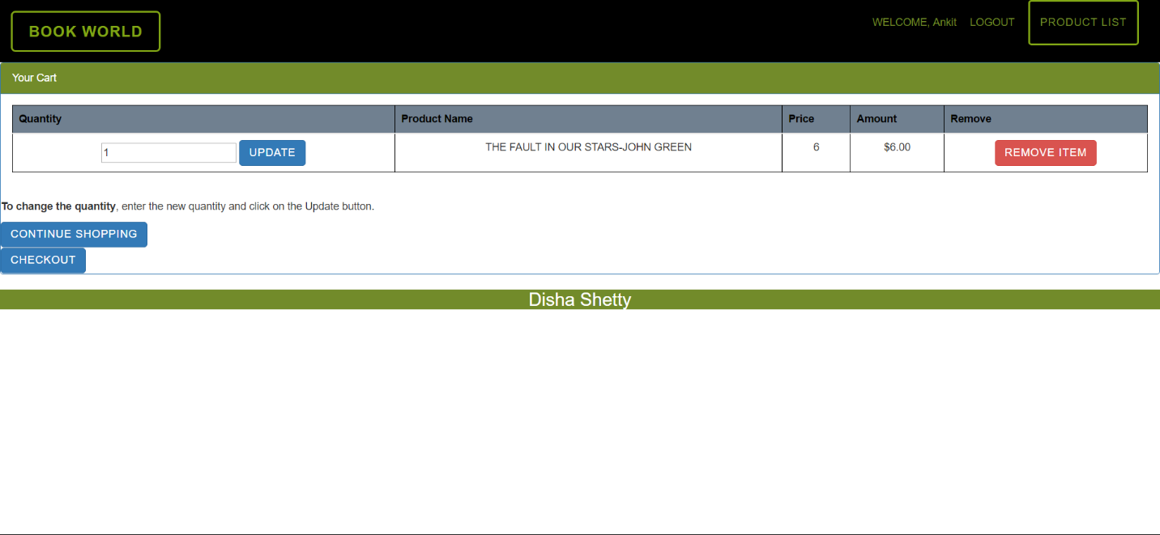

**Update**

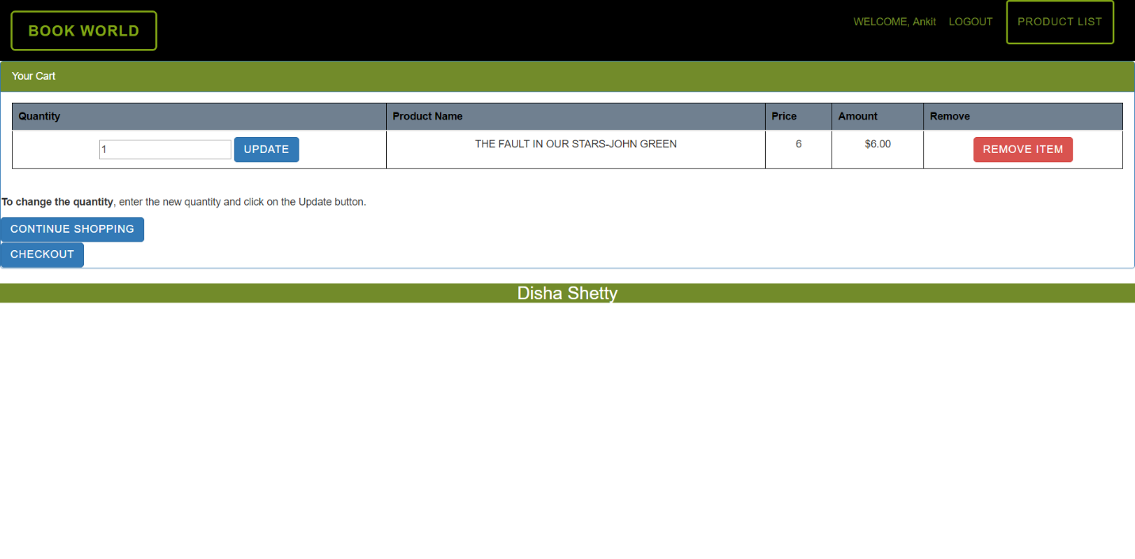

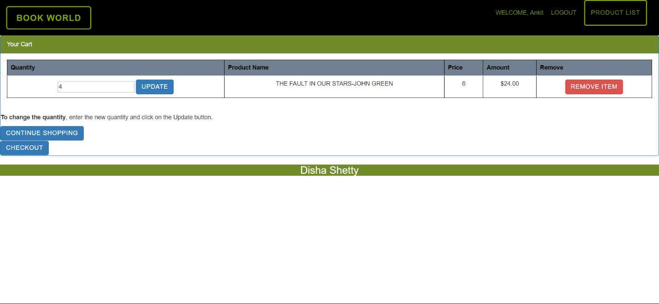

**Remove item- Customer cam remove a book from their cart**

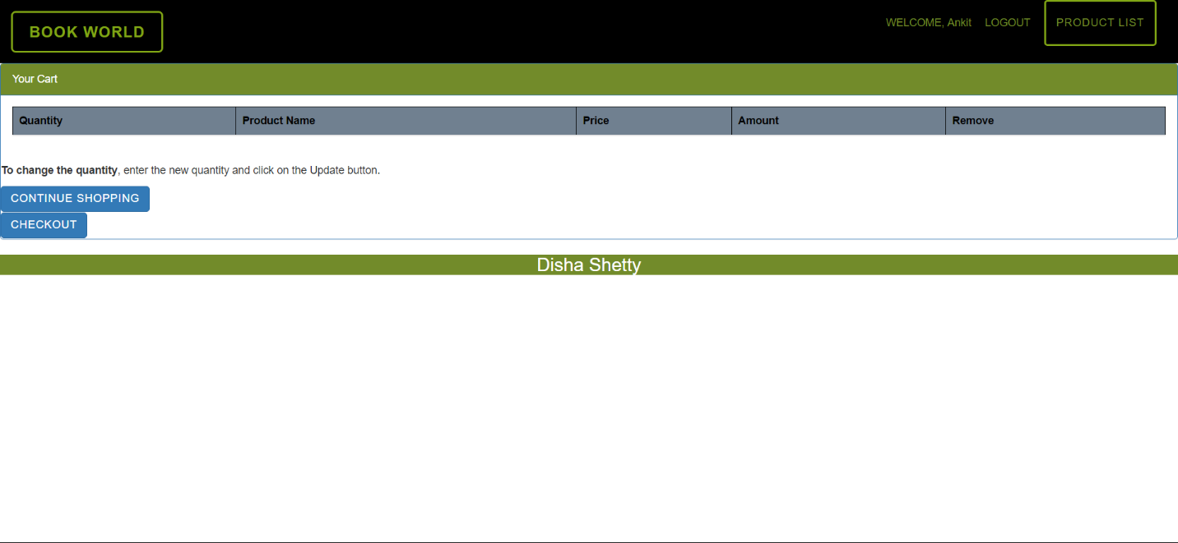

**Checkout- customer can check out items in their cart**

